Six reasons for participating in
CHINA DIECASTING 2019&CHINA NONFERROUS 2019!

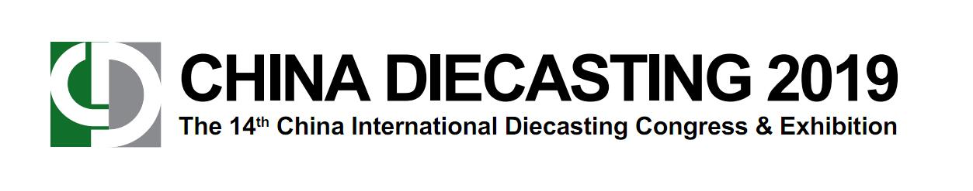
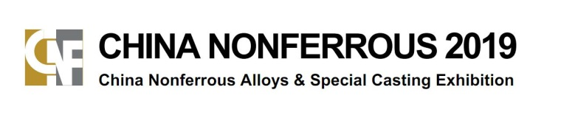
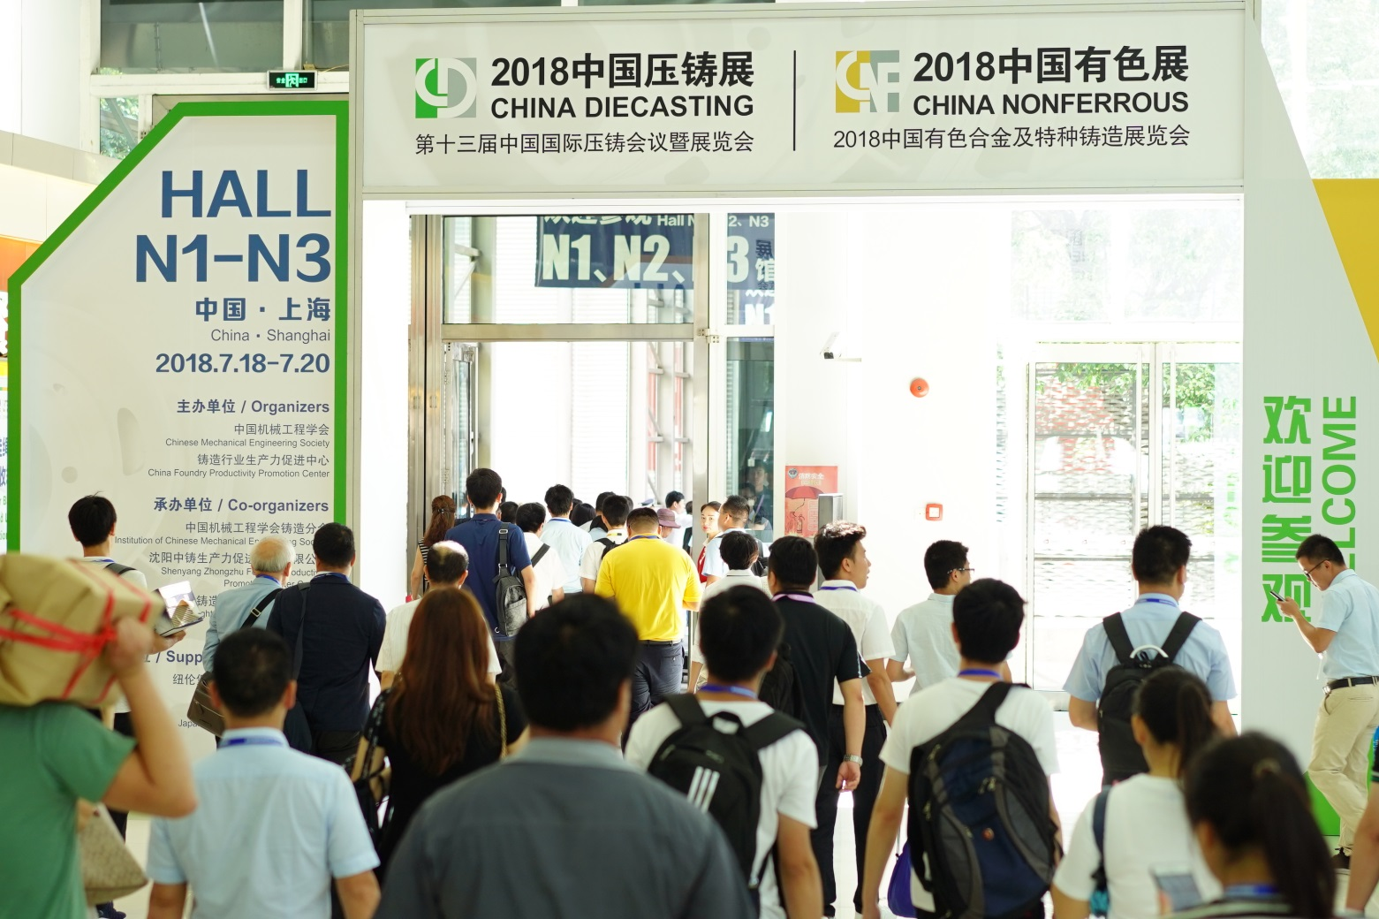
2019.7.17-19, Hall N1-N3, Shanghai New International Expo Centre (SNIEC)
20,000
Trade Visitors
500
Exhibitors
36,900 m²
Exhibition Area

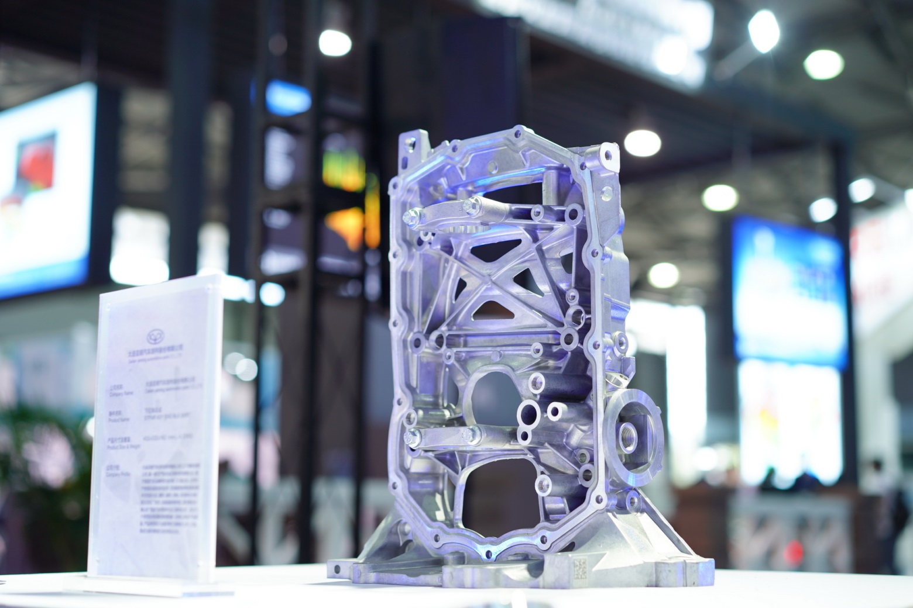
Six reasons for participating in
CHINA DIECASTING 2019 & CHINA NONFERROUS 2019!
1.
LARGEST

36,900 m²
Exhibition area,
The largest CID& CNF of all-time.
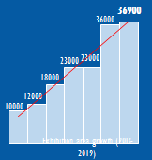

LEAD APPLICATION
Casting technologies on the most wanted applications market.
- Automotive lightweight
- Aerospace
- Ship & Marine
- Electrical tools
- Electronics & Telecom
- Lighting

3
CORE TECH
Showcasing the most advanced and valuable technologies.
- Lightweight casting
- DC real-time control
- Dies & moulds
- Green manufacturing
- Factory & plant solution
- Digital tech serving
- Counter Pressure
- Semi-solid casting

2
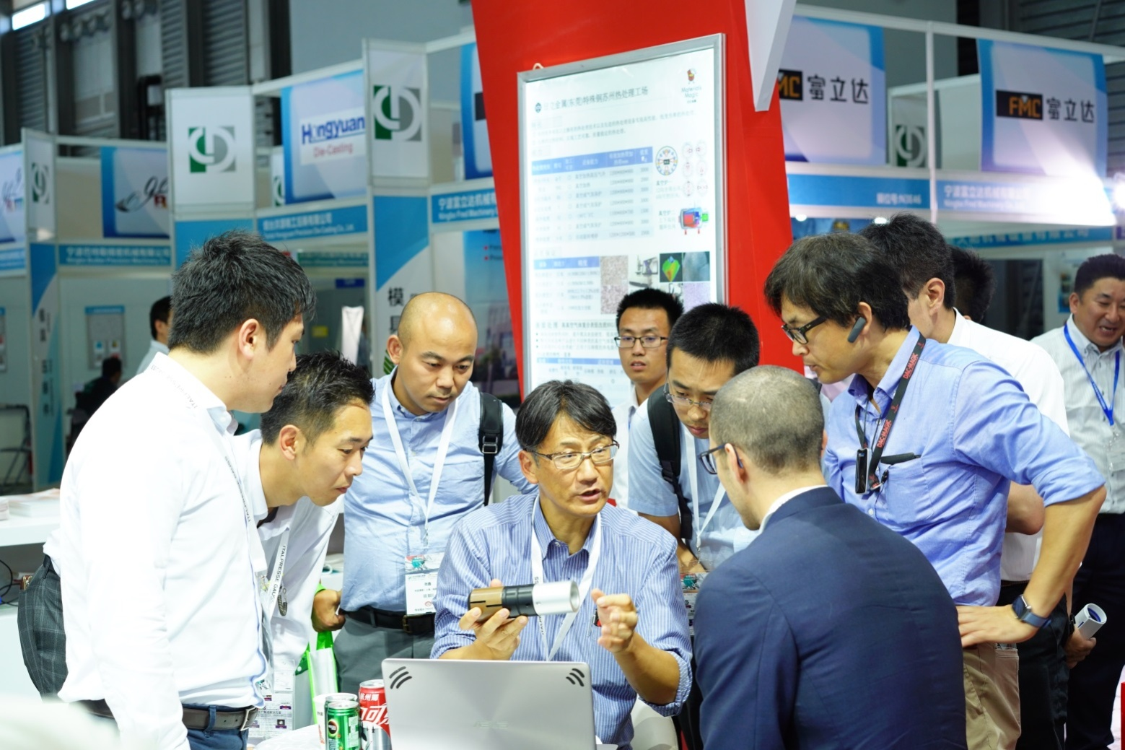
SERVICE WITH CARE
Professional and careful services to all exhibitors. Time-saved, show-focused
- Exhibitor service letter
- Marketing guide
- Events alarm
- Buyers invitation
- Exhibitor manual
- Move-in instruction
- Onsite services
6
5
MULTI-PROMOTION

Sufficient promotion options to various exhibitors via multi-channels.
- Online/offline magazine
- EDM and newsletters
- Online/Website
- Mobile-end advertising
- Ads on show maps
- Show daily
BUYER INVITATION
Invitation to direct and professional buyers.
- 3,000,000+ buyer DB
- Professional call-center
- Personalized invitation
- 20,000+ pre-show DM
- Direct sourcing needs
- Pre-screened buyers
- Particular visiting route
- Visiting guide
4

———————————————————————————————————————（分割线）

- 36,900 sqm in 3 halls of SNIEC (Hall N1-N3) breaks the new record of the exhibition area of CHINA DIECASTING and CHINA NONFERROUS

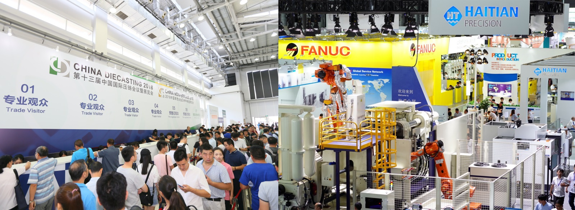
The exhibition area of CHINA DIECASTING 2019 and CHINA NONFERROUS 2019will reach 36,900 sqm. At the time, the 3 theme halls(Hall N1-N3) will bring together more than 500 exhibitors from home and abroad, and it is expected to attract more than 20,000 trade visitors from the die casting and nonferrous casting industry and casting application fields.

———————————————————————————————————————（分割线）

2. Gathering the whole industry value chain and releasing innovative solutions for production processes of die casting and nonferrous casting in one place

CHINA DIECASTING 2019 and CHINA NONFERROUS 2019 will bring together die casting foundries and their equipment suppliers, material suppliers, accessories as well as service providers, including die casting machines and plants, low pressure machines, counter-pressure machines, peripheral devices and systems, furnaces and accessories, after treatment of castings/CNC treatment, heat treatment and surface technology, molds and accessories, raw and auxiliary materials, quality assurance/control, simulation software, rapid prototyping/rapid tooling, etc.

CHINA DIECASTING and CHINA NONFERROUS strive to be at the forefront of the industry. Through exhibits and more than 10 technical sessions onsite, we will release and showcase the hot-spot solutions with innovation in the die casting and nonferrous casting production process to optimize the process flow and improve the energy efficiency: Structural casting, environmental protection and green production, intelligent manufacturing, digital factories, CNC machine tools, semi-solid die casting, magnesium alloy casting, etc..

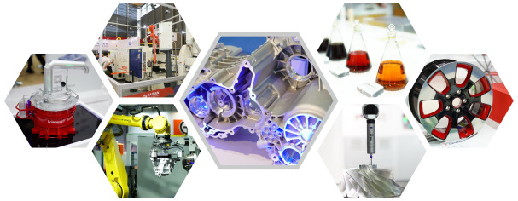

———————————————————————————————————————（分割线）

3. Exploring hot trends in application fields with advanced diecasting and nonferrouscasting parts

In 2019, nearly 100 diecasting exhibitors will be expected to present advanced aluminum, magnesium, and zinc diecasting parts. And at the onsite event “Global Best Die Casting Competition & Nonferrous Casting Display”, more than 70 diecasting companies will display140 pieces of castings from the applications, such as automobiles, electronics, electromechanical instruments, construction hardware, and electric tools. etc. Buyers, R&D, and quality engineers from the application fields will gather to discuss the hot trends of lightweight, EV Tech, 3C products and 5G base stations with die casting plants and nonferrous foundries.

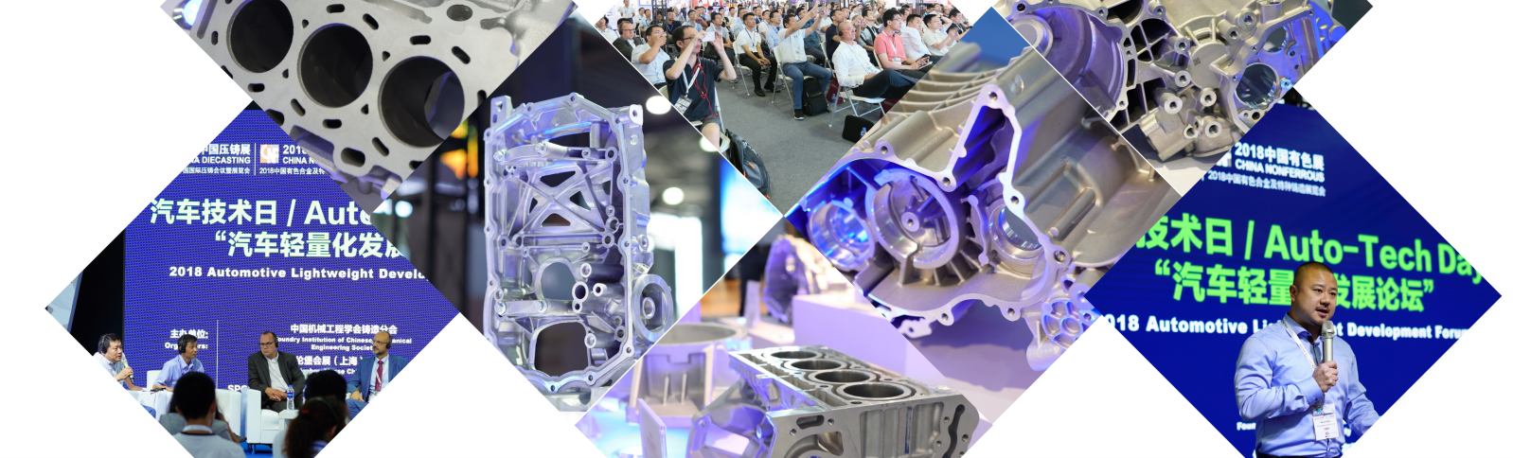

———————————————————————————————————————（分割线）

4.Inviting top-class professional audience and improving the matching efficiency of exhibitors and purchases

CHINA DIECASTING 2019 and CHINA NONFERROUS 2019 is an ideal platform for exhibitors to find target groups and build new business contacts. 90% of the 414 exhibitors in 2018 confirmed that they found the target group at the show. Before the 2019 exhibition, there will be a professional team to invite important buyers and trade visitors through comprehensive channels such as call center, customized invitation, and show preview DM, etc..The show will design special tour routes, and provide professional tour guides to enhance the matching efficiency of exhibitors and purchases.

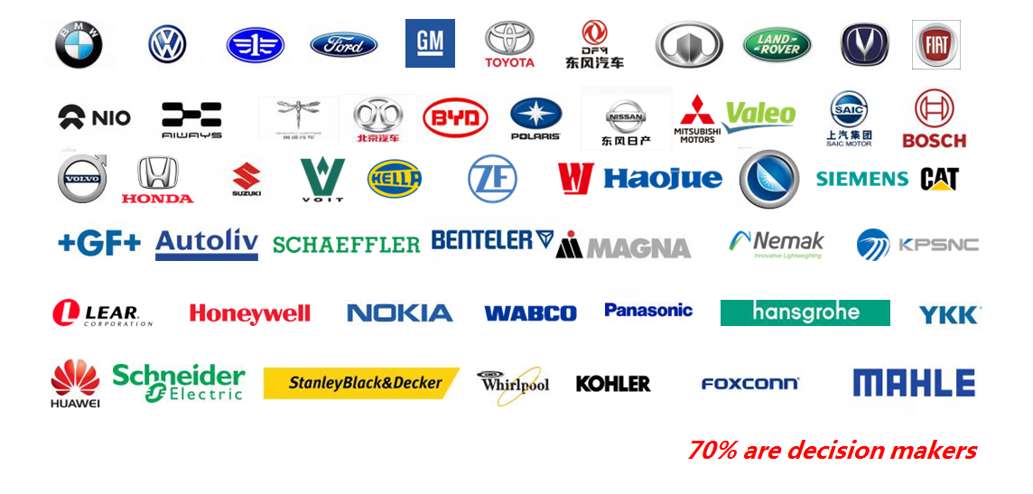

———————————————————————————————————————（分割线）

5. Providing multi-platforms, high-frequency, full-angle channels of brand promotion before, during and after the show

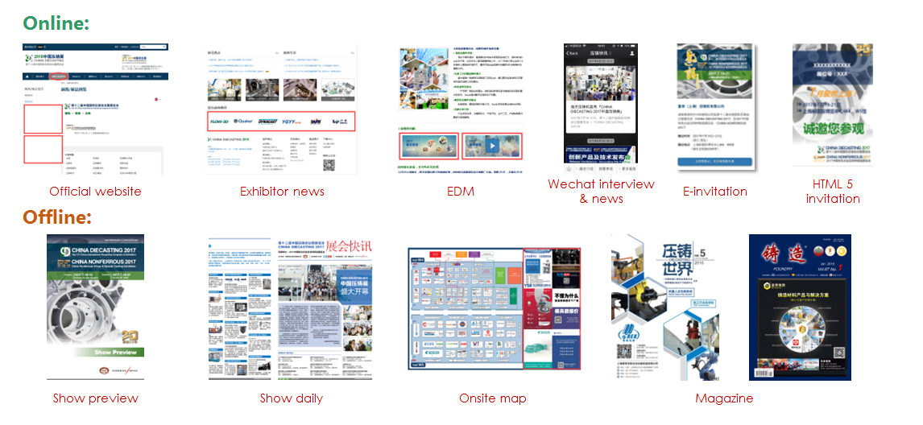

———————————————————————————————————————（分割线）

6. Offering people-oriented exhibitor services, and improving customer experience
Professional service models, such as exhibitor service letter, marketing brochure, exhibitor manual, one-to-one personal service, event reminder, onsite construction support, onsite exhibitor service, will save the time and cost for exhibitors, help you to focus on the exhibition.

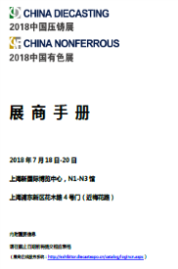
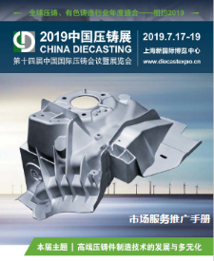
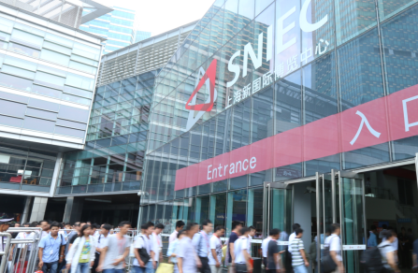
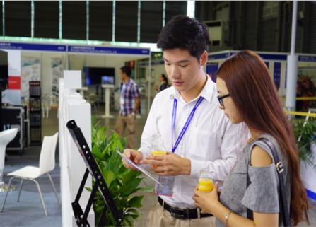

Onsite construction support, onsite exhibitor service
Exhibitor manual, exhibitor service letter
Wechat assistant：One-to-one personal service

———————————————————————————————————————（分割线）

Become Exhibitor Now! www.diecastexpo.cn/en/

Early birds enjoy 10% discount before 28 February, 2019!

Click to find “Invitation to Exhibition 2019”

Global Service Network
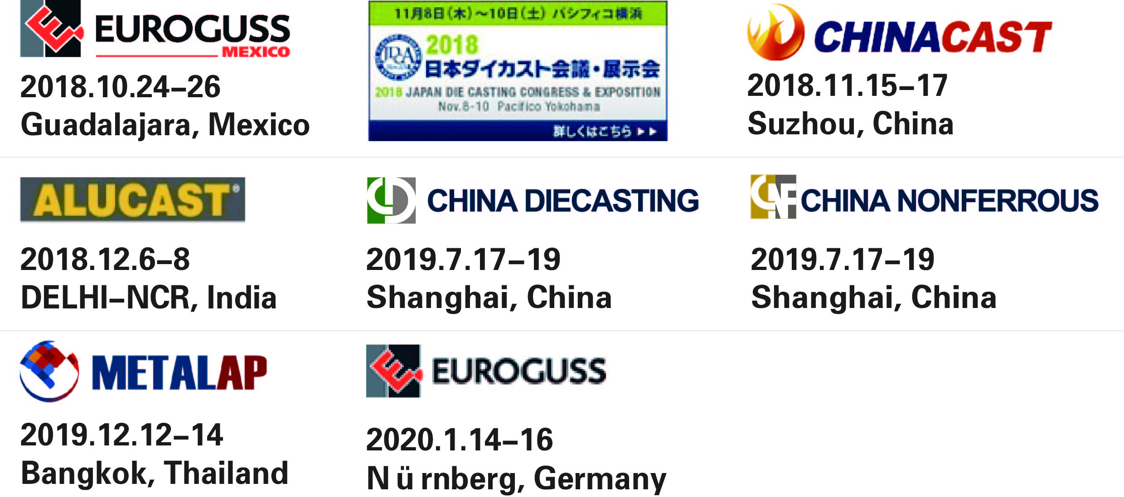

Any questions? Contact us!
Mr. William Gu
Tel: +86 (0)21 6036 1213
Email: william.gu@nm-china.com.cn



